**SMART ATTENDENCE SYSTEM WITH REAL-TIME FACIAL RECOGNITION USING JETSON NANO**

**A PROJECT REPORT**

***Submitted by***

**P CHINNI KRISHNA KOWSIK**

**(Reg. No CH.EN.U4CYS21011)**

**HOSUR UDAY REDDY**

**(Reg. No CH.EN.U4CYS21023)**

***in partial fulfillment for the award of the degree of***

**BACHELOR OF TECHNOLOGY IN COMPUTER SCIENCE AND ENGINEERING (CYBER SECURITY)**

## **Under the guidance of**

**Dr. S. UDHAYA KUMAR**

**Submitted to**

**AMRITA VISHWA VIDYAPEETHAM**

**AMRITA SCHOOL OF COMPUTING**

**CHENNAI – 601103**

**October 2024**



**BONAFIDE CERTIFICATE**

Certified that this project report entitled **“SMART ATTENDENCE SYSTEM WITH REAL-TIME FACIAL RECOGNITION USING JETSON NANO”** is the bonafide work of **P CHINNI KRISHNA KOWSIK (Reg. No CH.EN.U4CYS21011) and UDAY REDDY H (Reg. No CH.EN.U4CYS21023)**  who carried out the project work under my supervision.

**CHAIRPERSON SIGNATURE**

**Dr. SOUNTHARRAJAN S**

Associate Professor

Amrita Vishwa Vidyapeetham

Amrita School of Computing

Chennai.

**SUPERVISOR SIGNATURE**

**Dr. UDHAYAKUMAR S**

Associate Professor

Amrita Vishwa Vidyapeetham

Amrita School of Computing

Chennai.

**INTERNAL EXAMINER**

**EXTERNAL EXAMINER**



**DECLARATION BY THE CANDIDATE**

I declare that the report entitled " **SMART ATTENDENCE SYSTEM WITH REAL-TIME FACIAL RECOGNITION USING JETSON NANO**" submitted by me for the degree of Bachelor of Technology in Computer Science and Engineering ( Cyber Security) is the record of the project work carried out by me under the guidance of "**Dr. UDHAYAKUMAR S**" and this work has not formed the basis for the award of any degree, diploma, associateship, fellowship, titled in this or any other University or other similar institution of higher learning.

**P CHINNI KRISHNA KOWSIK**

**(Reg. No. CH.EN.U4CYS21011)**

**HOSUR UDAY REDDY**

**(Reg. No. CH.EN.U4CYS21023)**

**ABSTRACT**

This system aims to realize, for the first time, automation in attendance management in academic environments in a real-time manner based on face detection and recognition. Advanced facial recognition algorithms are employed on the NVIDIA Jetson Nano platform for the realization of this system as a modern efficient and accurate alternative to traditional attendance methods in the nature of roll calls and card swipes, which always have inefficiencies and errors due to humans. Whereas, proposed systems capture face images of the students in real-time and compare them with a pre-stored data set, while automatically uploading attendance records alongside their timestamps in an Excel sheet. By doing so, it streamlines the procedure so that it becomes accurate, saves time, and reduces the administrative burdens involved while tracking attendance. This is a significant innovation of the system: to capture and recognize multiple faces at once, which makes the attendance of groups feasible without missing a single student, even in huge classrooms. The system also automatically generates an absentee list through the detection of all students who are present by the automatic headcount feature.These functionalities enable the monitoring of the physical presence of people every second in real-time and therefore, recording attendance becomes easier and simple to manage. This means enhanced classroom management and better comprehensive records of attendance, be it by students or faculty. Also, the ability to determine attendance also enhances the systems strength and reliability regardless of the different conditions such as background noise and light intensity, the position of the persons visage and so forth. The Jetson Nano core makes this system powerful and cost-effective. It also has real-time facial recognition processing capabilities without requiring any high-priced hardware setup, hence making the system scalable for a few or large numbers of institutions.

**Keywords:** Face Recognition, Attendance Management, Real-time Detection, Jetson Nano, Automation, Machine Learning, Facial Encodings, Edge Computing, Multi-face Detection, Image Processing.

**ACKNOWLEDGEMENT**

This project work would not have been possible without the contribution of many people. It gives me immense pleasure to express my profound gratitude to our honorable Chancellor **Sri Mata Amritanandamayi Devi**, for her blessings and for being a source of inspiration. I am indebted to extend my gratitude to our Director, **Mr. I B Manikantan** Amrita School of Computing and Engineering, for facilitating us with all the facilities and extended support to gain valuable education and learning experience.

I register my special thanks to **Dr. V. Jayakumar**, Principal Amrita School of Computing and Engineering, **Dr. Sountharrajan**, Chairperson of Department of Computer Science and Engineering and **Dr. S. Udhaya Kumar**, Program Head Department of CSE(CYS) for the support given to me in the successful conduct of this project. I wish to express my sincere gratitude to my supervisor **Dr. S. Udhaya Kumar**, Associate Professor, Department of Computer Science and Engineering and co-supervisior **Dr. P. Mathivanan,** Assistant professor, Department of Computer Science Engineering (Cybersecurity), for their inspiring guidance, personal involvement and constant encouragement during the entire course of this work.

I am grateful to the Project Coordinator, Review Panel Members and the entire faculty of the Department of Computer Science & Engineering, for their constructive criticisms and valuable suggestions which have been a rich source to improve the quality of this work.

**P. CHINNI KRISHNA KOWSIK**

**&**

**HOSUR UDAY REDDY**

**TABLE OF CONTENTS**

|  |  |  |
| --- | --- | --- |
| **CHAPTER NO.** | **TITLE** | **PAGE NO.** |
|  | **Abstract** | **iv** |
|  | **List of Tables** | **x** |
|  | **List of Figures** | **xi** |
|  | **List of Symbols and Abbreviations** | **xii** |
| **1** | **INTRODUCTION** | **1** |
|  | 1.1 Background Study | 1 |
|  | 1.2 Advancements in Facial Recognition System for Attendance System | 2 |
|  | 1.3 Problem Identification | 3 |
|  | 1.4 Significance and Motivation | 4 |
|  | 1.5 Objective and Scope of the Project | 5 |
|  | 1.6 Challenges in Real Time Facial Recognition on Edge Systems  1.7 Hardware and Software Integration | 6  7 |
| **2** | **LITERATURE REVIEW** | **9** |
|  | 2.1 Literature Review Based on Previous Research Papers | 9 |
|  | 2.2 Literature Summary Table | 12 |
|  |  |  |
| **3** | **METHODOLOGY** | **16** |
|  | 3.1 Problem Statement | 16 |
|  | 3.2 System Architecture and Overview | 17 |
|  | 3.3 Data Collection and Preprocessing | 18 |
|  | 3.4 Face Detection Algorithm Implementation | 19 |
|  | 3.5 Facial Recognition and Encoding Process | 20 |
|  | 3.6 Integration with Jetson Nano for Edge Computing  3.7 Database Design and Management for Attendance Records  3.8 Real-Time Attendance Marking Workflow  3.9 Handling Environmental Variations  3.10 Testing, Validation, and Accuracy Evaluation | 21  21  22  23  23 |
| **4** | **SYSTEM DESIGN** | **24** |
|  | 4.1 Overview of System Design | 24 |
|  | 4.2 Hardware Configuration | 24 |
|  | 4.2.1 Jetson Nano as Processing Unit | 24 |
|  | 4.2.2 Camera Module | 25 |
|  | 4.2.3 SD Card Setup | 26 |
|  | 4.2.3.1 SD Card Formatter  4.2.3.2 Flashing the SD Card | 26  26 |
|  | 4.3 Software Architecture  4.3.1 Operating System  4.3.2 Programming Languages  4.3.3 Software Components  4.3.3.1 Facial Recognition Algorithm  4.3.3.2 Web Frameworks | 28 |
| 28 |
| 28 |
| 29 |
| 29 |
| 30 |
|  | 4.4 Database Design and Management | 30 |
|  | 4.4.1 Database Selection | 30 |
|  | 4.4.2 Database Scheme Design | 31 |
|  | 4.4.3 Data Management Strategies  4.5 Integration with Jetson Nano for Edge Computing  4.5.1 Jetson Nano Configuration  4.5.2 Data Flow Architecture  4.5.3 Performance Optimization Techniques | 31 |
| 32 |
| 32 |
| 33 |
| 33 |
| **5** | **IMPLEMENTATION AND RESULT ANALYSIS** | **34** |
|  | 5.1 Flowchart Analysis of System Workflow | 34 |
|  | 5.2 Image Segmentation: Equally Sized Cells and Face Detection | 35 |
|  | 5.3 Threshold Value Calculation for recognition accuracy | 35 |
|  | 5.4 Flask Interface: Real-Time Results and System Instructions | 36 |
|  | 5.5 Facial Landmarking: Nodal Points and Eye Angle Detection  5.6 Database Management and Attendance Records  5.7 Real-Time Processing: Frames per Second (FPS) Analysis  5.8 Comparison of Biometric Modalities | 37 |
| 38 |
| 39 |
| 40 |
| **6** | **Conclusion and Future Work**  6.1 Conclusion  6.2 Further Work  6.3 Final Thoughts | 41 |
| 41 |
| 42 |
| 43 |
|  | References | 44 |

**LIST OF TABLES**

|  |  |  |
| --- | --- | --- |
| **TABLE NO** | **TITLE** | **PAGE NO.** |
| 2.1 | Literature Summary Table | 13 |
| 3.1 | Different views of data | 18 |
| 3.2 | Table for Student entries | 22 |
| 3.3 | Table for Teacher entries | 22 |
| 4.1  4.2 | Student Information Table Structure  Teacher Information Table Structure | 31  31 |

**LIST OF FIGURES**

|  |  |  |
| --- | --- | --- |
| **FIGURE NO.** | **TITLE** | **PAGE NO.** |
| 3.1 | Architecture Diagram | 17 |
| 3.2 | Feature Collection & Extraction Table | 19 |
| 3.3 | Camera Arrangement in a Classroom | 20 |
| 3.4 | Face Encoding Image | 21 |
| 4.1 | Diagram of Jetson Nano | 25 |
| 4.2 | Flashing the Jeton Nano img into SD Card using balenaEtcher | 27 |
| 5.1 | Flow Chart of System Workflow | 34 |
| 5.2 | Segmented Image | 35 |
| 5.3 | Threshold of centered pixel 4 | 36 |
| 5.4 | Image of Frontend using Flask | 37 |
| 5.5 | Image of Frontend using Flask (2) | 37 |
| 5.6 | Nodal Points on face | 38 |
| 5.7 | Angle between Eyes and Nose | 38 |
| 5.8 | Connection between recognition and Attendance Management System | 39 |
| 5.9 | Attendance Records stored in Excel sheet | 39 |
| 5.10 | Real Time performance in Frames per second | 40 |
| 5.11 | Biometric Modalities Comparison | 40 |

**LIST OF SYMBOLS AND ABBREVIATIONS**

FPS – Frames Per Second

ROI – Region of Interest

GPU – Graphics Processing Unit

RTP – Real-Time Processing

SoC – System on Chip (Jetson Nano's architecture)

SSD – Single Shot Multibox Detector

OCR – Optical Character Recognition

RNN – Recurrent Neural Network

GAN – Generative Adversarial Network

LBPH – Local Binary Patterns Histogram

RFID – Radio Frequency Identification

CNN – Convolutional Neural Network

DNN – Deep Neural Network

RTP – Real-Time Transport Protocol

TPR – True Positive Rate

FNR – False Negative Rate

**CHAPTER 1**

**INTRODUCTION**

* 1. **BACKGROUND STUDY**

Recently, much has changed in education and management practices. Rapid technological developments for the past few years have dramatically influenced the way things are done in educational institutions. Its use has changed so much about many aspects of school life, not to mention attendance management. For many years, paper-based roll calls and attendance sheets have been the conventional method used in taking the attendance. However, it poses so many issues. These methods, not only consume time but are also error-prone-entries like miss entries or recording of each one of them. Moreover, management of attendance for large classes will become unwieldy, thus turning to be inefficient and with delayed reports, a lack of accountability [1]. These traditional systems have proved rather ineffective and are increasingly apparent to be unable to suit large educational establishments; tracking attendance among students on a daily basis is of utmost importance to keep checks on engagement and participation. These methods also lack real-time data, which many educators and administrators need to make fast judgments of decisions. The whole process, of course, leaves room for errors in attendance being recorded and sometimes going in late that goes to the effect reporting and analysis. Automated attendance systems became one of the attractive means in pursuit of enhancing the smooth running of educational institutions and bettering the student experiences. Usually high end technologies like biometrics power them and provide a more reliable and accurate source of identification and tracking of people's attendance. This application calls for biometric solutions, where the use of this system is ideally suited because they eliminate the need for manual input, hence a reduction in errors by a magnitude, and collected data is real and up to date [3].

Among all the biometric technologies available, the emerging facial recognition has risen as Facial recognition technology is one of the promising solutions for attendance management. Unlike other methods of biometric identification like fingerprint scanning and iris recognition, facial recognition doesn't involve intrusion and, therefore, is convenient and does not disturb the learning environment as it can be read from a distance. It captures and analyzes the unique features of an individual's face thus performing fast identification and verification. This not only accelerates the recording process but is also more precise and trustworthy than with the manual method [4]. The development of facial recognition technology, even for mere attendance systems, symbolizes the growing need for more advanced solutions that solve the problems created by older methods. The enhanced hardware along with the advanced machine learning algorithms, such that can be used in designing facial recognition systems, enable very high accuracy even under difficult conditions like varying lighting, facial angles, and differences in student appearance as shown in fig.3.3. For this reason, these systems have applications in educational settings whereby near real-time feedback and reporting can be made to teachers and administrators. FRAMS is one solution that typifies a fully comprehensive solution especially designed to address traditional attendance-tracking methods that happen to be inefficient in most cases. FRAMS leverages the power of facial recognition, providing an easier way of correctly managing attendance and ensuring an all-round smooth experience for educators and students. This system will give real-time data, easy integration into any existing educational management platforms, and scale down the administrative burden from monitoring of attendance. Additionally, FRAMS can scale up to any large institution [7].

* 1. **ADVANCEMENTS IN FACIAL RECOGNITION SYSTEM FOR ATTENDANCE SYSTEM**

One of the technologies which has developed rapidly over the last few years is facial recognition, mainly because of advances in algorithms, machine learning techniques, and increased computational power. These advances propel facial recognition from being merely conceptual to practical ones widely applied in different sectors such as security, consumer electronics, and very recently, education. Improvements in machine learning frameworks, mostly in deep learning architectures, have enabled these advances to greatly accelerate the accuracy and efficiency of facial detection and recognition systems [8]. Among the most influential findings has been the use of Convolutional Neural Networks (CNNs) as shown in 5.6, designed to mimic human vision as closely as possible. The CNN is pretty good at extracting the patterns from images, so its applicability is almost perfect for facial recognition purposes. Such a network analyzes several features of the face such as the eyes, nose, and mouth, then compares them to similar data stored beforehand to confirm the identity of the person. For example, the ability of CNNs to generalize over differences in lighting and facial angles or partial occlusions makes it critical to enhance the robustness of facial recognition systems. Integrating deep learning techniques like Residual Networks (ResNets) and FaceNet also comprised a significant share of advancement of refinement in facial recognition. Such models are capable of learning complex features of images of the face, with enhanced recognition accuracy to levels where the technology is now deployable for real-time applications, such as attendance management in educational institutions. The accuracy and reliability of such systems are improved further by incorporating pre-trained models that can be fine-tuned specifically for specific datasets to meet the particular requirements of different educational environments [3].

Yet another major development is 3D facial recognition that uses depth-sensing technology to capture facial contours in unprecedented detail. The technique smoothes out some of the limitations that attended 2D facial recognition, such as being hugely sensitive to lighting conditions or changes in appearance (hairstyle, for example, or glasses) as shown in fig.3.1. Three-dimensional recognition introduces another aspect of security and accuracy, by letting the system know whether it can have a safe identification of persons, with reduced to perfect conditions. The hardware aspect is continuously improving, and the edge computing brings more feasibility and practicality into facial recognition systems. A good example is the NVIDIA Jetson Nano, which has allowed a local deployment of facial recognition algorithms outside the processing on cloud, reducing latency, and can run even in partial internet environments. Edge computing also enhances the system security since facial images as such sensitive data are processed and stored locally, thus preventing exposure of information to leakage through communications [9]. Attendance management goes towards new technologies that engender fully automated solutions instead of the traditional manual or semiautomated systems. In fact, such an attendance system based on facial recognition can immediately recognize entering students one by one in a class so as to record, without interruption and on time, the attendance of the whole group. The process is continuous so that real-time data can be obtained and directly accessed by teachers and administrators. In this automation, there is accuracy and convenience, and so it is done easily and not be bothered with the bureaucratic paper work of recording attendance.

* 1. **PROBLEM IDENTIFICATION**

Manual attendance systems, as well as biometric traditional attendance systems, face many problems in terms of accuracy, efficiency, and security. Manual attendance is very time-consuming in school. It is prone to human error and susceptible to fraud. Educators spend too much time sitting in class taking attendance, thereby wasting valuable instructional time. Most importantly, the manual process has proven to be very error-prone and prone to proxy attendance where students sit in for absent students. Such errors call for a much more dependable and secure automatic system that can maintain students' records and time attendance. Biometric systems like fingerprint scanners have been brought in place to help counter some of these drawbacks, but there are other critical disadvantages associated with such systems as well. For instance, fingerprint systems will force children to physically touch devices just to access them. This can potentially call for hygiene problems, especially at a time when the world is bedeviled by mass pandemics. More than that, such systems are often slow; therefore, using them in larger classrooms with hundreds of students will significantly prove to be quite impractical, thus frustrating the students and instructors. Scalability is another massive issue. Managing attendance data can be a logistical headache for large organizations, especially ones with large populations of customers, where possibly hundreds or thousands of students could mean hundreds of staff members managing records. Existing systems are mostly manual and inefficient to use with most especially any real time reporting mechanism completely absent and there is a lot of data entry work to be done before attendance statistics can be obtained. Intrinsically, the monitoring of attendance of students spans over time gives rise to another level of the aggravation. Other than workforce efficiency, data security and privacy issues come to play with modern biometric systems. All risky biometric data including fingerprints would be kept in a tamper-proof manner to prevent any access by third parties thereby calling for high-level security provisions which none of the existing systems seems to have implemented effectively. Thus, there is an increased need for an attendance management system that is advanced and automated. Facial recognition technology is contactless, efficient, and highly accurate in its approach. It can bridge the limitations imposed by conventional methods by automating the attendance through face recognition in it. At the same time, it introduces complications arising from computationally limited environments and variability, which edge devices like Jetson Nano will have to conquer along with others to ensure the effectiveness of the system.

* 1. **SIGNIFICANCE AND MOTIVATION**

The significance of this project is in the perspective of revolutionarizing attendance management within educational institutions. It assures full automation of the process of attendance, so it not only increases accuracy but also decreases administrative burden on educators by making them more available for teaching rather than administrative work [12]. This is an online attendance record that helps immensely in the assessment of performance and participation by students and thus achieves the pursuit of this project based on the need to increase students' accountability and engagement. Such a system also promotes the overall drive of digitalization in education, wherein technology is synonymous to improvement in the learning process. Besides being a shortcut in attendance tracking, the use of facial recognition technology also promotes the culture of innovation in the institutions since it instills technological advancement in the class as shown in 3.3.

* 1. **OBJECTIVE AND SCOPE OF THE PROJECT**

This project idea aims to design and implement a Smart Attendance System With Real-Time Facial Recognition Using Jetson Nanothat can automatically capture and manage students' attendance in real-time for colleges. It will use the advanced algorithms of facial recognition, along with edge computing capabilities, to ensure its seamless performance with great accuracy as a solution for educational environments. Project: This project attempts to bring about revolutionary change in the management of attendance in all types of institutions by eliminating manual and semi-automated methods, which are often inefficient and inaccurate.

Scope of the Project: The scope of the project runs across the following areas. It involves the integration of both hardware and software components so that the facial recognition system would properly work on the edge device, for example, Jetson Nano. The overall design and development of the system cover everything, from developing an easy-to-use interface for educators to monitor and manage attendance records to making sure the facial recognition component operates reliably under conditions that vary. The overall key objectives of the project are: S

* Developing a user-friendly interface: The system will have an intuitive interface that allows teachers to easily access, monitor, and manage attendance records. This kind of interface will provide real-time data on student attendance, making it accessible to teachers and administrative staff.
* High accuracy of the facial recognition: The system is bound to be low on false positives, meaning that the students do not mistake other students, and false negatives, meaning that students who are there don't go unnoticed; it uses higher algorithms to find faces and match them to a pre-existing database.
* Flexibility to multiple environmental conditions: It will be able to recognize faces in partial shadow or camouflage and at different angles, which makes it more practical in real-life settings.
* Real-time reporting capabilities: The most important feature is generating attendance reports. Immediately after a student gets inside the class, the attending record will be taken and immediately available to teachers without any backlog.

Implementation challenges of facial recognition on edge devices such as limitation in terms of computational power, among others, shall be analyzed, and best solutions will be suggested to keep the precision and efficiency of the system. Its functionality should be possible in real academic settings where conditions differ and change.

* 1. **CHALLENGES IN REAL-TIME FACIAL RECOGNITION ON EDGE DEVICES**

Although facial recognition technology has shown great strides, its real-time inference on a device like Jetson Nano still presents challenges unique to it. Such needs will be fulfilled only when the system is able to work at its best and has served educational institutions.

* Computational Limitation: Unlike cloud-based systems or traditional desktop computers, edge devices limit processing power, memory, and energy resources. This will lead to significant performance bottlenecks when running applications that consume strong resources, like real-time facial recognition. The first aim of the project is to create optimized algorithms that can be run on power-constrained devices without any impact on accuracy levels. This includes selecting computationally lightweight versions of machine learning models that can feasibly run on an edge device and, if necessary, fine-tuning these models for performance that why we are using Jetson nano as shown in fig.4.1.
* Environmental Variation: It can be said that environmental factors, such as lighting conditions, facial angles, or background noise, significantly affect the performance of facial recognition systems. In real classrooms, students may enter from different angles or via various lighting conditions as well, which can influence the ability of the system to maintain consistency regarding high accuracy. The system will thus be designed in such a way to incorporate adaptive algorithms accounting for environmental changes. We leverage some of the data augmentation techniques, like changing light intensity during training, in order to enhance the generalization capability of the system across conditions as shown in 3.1.
* True-Time Processing Requirements: The edge devices, in this project, naturally favor real-time data processing without depending on the cloud infrastructure. The success of this project depends entirely on real-time processing [13]. For that, the system will be highly optimised code and hardware acceleration features such as GPU processing on the Jetson Nano board, making sure face recognition tasks are performed well within acceptable time frames without any noticeable delay.
* Data Privacy and Security: As the system handles sensitive biometric data (facial images), data privacy and security issues must be addressed. The system will ensure that encryption techniques are robust enough to store and forward the biometric data securely. Data will be protected according to any privacy regulations, including GDPR.
* Dataset Quality and Diversity: Facial recognition systems rely on the quality of the training data. Poor-quality image or datasets degrade system results to biased or inaccurate ones. Diversity in the dataset will cover numerous faces, a wide variety of lighting conditions and angles to generalize the system for application in different classroom settings.

It addresses the project by ensuring that the robust, efficient facial attendance management system can be performed reliably in real-world educational environments. Answers may include optimized models of machine learning, adaptive algorithms, hardware accelerations, and high-security measures concerning data that will make a good follow-through of such a system.

* 1. **HARDWARE AND SOFTWARE INTEGRATION**

The effective combination of both hardware and software components will define the success of the implementation of the Smart Attendance System With Real-Time Facial Recognition Using Jetson Nano. In this regard, the chosen hardware platform was actually the Jetson Nano, which is a compact but still a reasonably powerful edge computing device specially designed to run machine learning and artificial intelligence tasks. This was the suitable support for the running of resource-intensive tasks such as real-time image processing and facial recognition. This ensures that the system can run efficiently without losing speed or accuracy even in resource-scarce environments. On the software side, the system is coded using Python, a highly versatile programming language for machine learning and image processing. The different frameworks of python, for instance, OpenCV for images and face_recognition for locating and identifying faces made it easier to implement the system. This means it captures and processes facial images as they come, which means that once the students enter into the class, they will be recognized within no time and accurately [7]. On the client end, we have developed a very light web framework called as Flask so that an easy application can be built for the teachers for managing and viewing the attendance. This web interface also provides an additional advantage that a teacher can view the class attendance over the web rather than using the internal system. This makes it easier for the teachers to log into the system to monitor and record attendance status as well as generate attendance reports as shown in table 4.2 and 4.3. The close relationship between the software and hardware components makes sure that this attendance system which is built using facial recognition can be seamlessly used in an educational setup for the reasons of precision, extendibility, and ease of use. On the other hand, the integration of the Jetson Nano board together with the prosthetic hardware, the various ML libraries in python, and the flask web-based interface makes the system a well functioning one without any glitches in this sector of educational institutions [19].

**CHAPTER 2**

**LITERATURE REVIEW**

**2.1. LITERATURE REVIEW BASED ON PREVIOUS PAPERS**

Bao-Thien Nguyen-Tat, Minh-Quoc Bui, Vuong M. Ngo et. al[1] proposed on Automating attendance management in human resources: A design science approach using computer vision and facial recognition. The paper goes ahead to explain pothole detection through deep learning models in a real time NVIDIA Jetson Nano-based system for infrastructure inspection in urban area. There were neural network models that underwent training. Potholes Images; those were gathered in the urban setting. The system managed to come up with fairly promising results in real time about the detection of potholes. One of the limitations would be observing on case of scenario environmental condition, varies greatly because of variations in detection accuracy. More numbers of sensors can be integrated for better accuracy.

Thai-Viet Dan*g* et. al[2] proposed on Smart Attendance System based on improved Facial Recognition. The paper proposed an automation system in attendance through a face recognition system, thereby making the process more efficient and error-free in attendance management. To detect the faces, it made use of the Haar Cascade and to recognize it, it made use of the LBPH. A Dataset of the students images along with their information. It also showed the accuracy level in detecting the attendance. With the presence of illumination variation, the face cannot be identified. Developing more algorithms to implement to identify faces in regard to varying lights.

Pham Ngoc Giaua, Bui Nhien Locc, Tran Quang Hiend, Tong Le Thanh Haie, Tran Hong Ngocc et. al[3] proposed on An Effective Approach To Face Recognition With Artificial Intelligence And The Internet Of Things Usnig NVIDIA Jetson Nano. The Paper describes how the use of Convolutional Neural Networks could enhance the Smart Attendance Management System in Academic Institutions. The Proposed Custom CNN Architecture for Face Identification. The Collection of images of students' faces through sessions. The proposed architecture reached up to 99% accuracy. It needed a very high amount of data to train, and it worked in an environment that required constant illumination. There was an increase in the dataset and exploration of the transfer learning, which will eventually enable the system to be robust.

Sudha G Sadasivam, Shanmuhappriya Muthukrishnan, Harismithaa Lr et. al[4] proposed on Multimodal Approach to Identify Attention Level of Students using Jetson Nano. This work discusses an IoT and cloud-based attendance management system implemented using RFID technology for the automatic tracking of attendance. The developed RFID tag reading and data processing through AWS. RFID tags assigned to the students. The developed system allowed real-time tracking of attendance and reporting. Non-availability of network connectivity. Further features like biometric authentication can be included in the system to enhance security.

Anuj Singh, Nikhil Rawat, Rajan Kesri et. al[5] proposed on Face Recognition Based Attendance System. This paper proposed a smart classroom attendance management system by using RFID and face recognition technologies. RFID technology for identification and Face Recognition technique for verification. Student's attendance record and their facial images. The system successfully recognized the students and marked their attendance. Mistakes due to obstructions and environmental impacts. Algorithms to be developed for enhancing the accuracy of recognition in different settings.

Alya Khairunnisa Rizkita, Rahman Indra Kesuma, Martin Clinton Tosima Manullang et. al[6] proposed on Smart camera for visitor recording based on face recognition in automatic gates. A paper is coming up with an attendance system having uses fingerprint recognition, which aims to make it automatic in educational institutes for tracking attendance. Fingerprint Scanning and Verification Algorithm. Fingerprints of Students and Employees. It has significantly minimized errors that occurred by taking the manual attendance. During the implementation by scanning fingerprints, it becomes hardware dependent. The deployment can be made more user friendly with the use of mobile integration.

Marius-Emanuel Obreja & Dan-Marius Dobrea et. al[7] proposed on Pothole Detection Using Jetson Nano Embedded System – An Evaluation of Training Models. This paper is an intelligent student attendance monitoring system using the smart IoT and RFID system for tracking students in an institute. RFID readers were integrated with GSM for sending notices. Student IDs are allotted with RFID tags. The proposed system enhances the accuracy and reduced the time workload. High limit on the range of RFID and network connectivity. GPS can be added for tracking the location of students

M Sornalakshmi, M J Abinash, S Gopalakrishnan, R Kasthuri, C M Nivedhitha Harini, K Balamurugan et. al[8] proposed on Deep Learning-Powered Face Recognition Attendance System: A Novel Approach to Automated Prediction. This paper discusses the development of face recognition attendance system based on Raspberry Pi and OpenCV, which would relieve the process of attendance. LBPH face recognition algorithm. Images of face of students for training. The proposed system could minimize proxy attendance and improved the record-keeping. Environmental issues concerning lighting while capturing the face. It can use advanced techniques to reduce the impact of lighting.

Bharathy G.T, Ms S Bhavanisankari, Tamilselvi Tt et. al[9] proposed on Smart Attendance Monitoring System using IoT and RFID. This paper discusses an IoT-based smart attendance system designed by using RFID technology for the simplification of attendance processes in schools and colleges. The algorithm that was used in this model is scanning through RFID and collecting data through cloud services. Unique RFID tags were allocated to every student. Since it gives real-time attendance information, its efficiency has been improved. The challenge in this model has arisen from the dependence on the reliability of RFID tags. The future work would be the application of machine learning for predictive analytics in the attendance patterns.

Syam Kakarla; Priyaranjan Gangula; M.Sai Rahul; C. Sai Charan Singh; T. Hitendra Sarma et. al[10] proposed on Smart Attendance Management System Based on Face Recognition Using CNN. This research work suggests deep learning-based smart attendance with improved accuracy and efficiency in the attendance management process. Deep learning models for face detection and recognition. Large dataset of student images. It was able to yield a good accuracy rate in the recognition of students. Data privacy concerns, training requirements for the model. Privacy-preserving technique in attendance systems

Rajarshi Samaddar, Aikyam Ghosh, Sounak Dey Sarkar et. al[11] proposed on IoT & Cloud-based Smart Attendance Management System using RFID. The need for automation in the attendance process by using a hybrid of RFID and facial recognition technologies. The required algorithms are combinations of RFID reading and face recognition. Collected data from student attendance records. This hybrid system highly enhances reliable attendance tracking capabilities. In addition, because of environmental conditions, this too suffered for accuracy in recognition. Depending on further enhanced biometric options, further improvization may be performed on the accuracy.

Md. Humaun Kabir, Sujit Roy, Md. Tofail Ahmed, Dr Mahmudul Alam et. al[12] proposed on Smart Attendance and Leave Management System Using Fingerprint Recognition for Students and Employees in Academic Institute. This paper designs a web-based attendance management application based on fingerprint recognition. Fingerprint recognition algorithms tied to a web application. Student and employee fingerprint databases. Successfully automated the attendance management process. The complexity of fingerprint hardware implementation. Future Scope includes developing a mobile application for easy usability by users.

Mingtao Zhao, Gang Zhao, Meihong Qu et. al[13] proposed on College Smart Classroom Attendance Management System Based on Internet of Things. The work develops a smart classroom attendance management system based on face recognition and IoT. Adopted Neural network for face recognition and protocols for IoT communication. Captured images of students in classroom environments. Improved attendance tracking with less time being taken to enter manually. Variability in student positioning leads to poor recognition. Further research using adaptive algorithms for better accuracy of recognition.

A Arjun Raj, Mahammed Shoheb, K Arvind, K S Chethan et. al[14] proposed on Face Recognition Based Smart Attendance System. The paper is on Machine learning algorithms for data analysis. Historical attendance data from the institution. Enhanced predictive capabilities concerning the trends of attendance. Data quality and completeness issues. It is possible to combine this system with even more superior analytics techniques.

Sakshi Patel, Ravi Kumar et. al[15] proposed on Face Recognition based smart attendance system using IOT. This paper deals with the integration of IoT along with facial recognition in order to effectively track real-time attendance within an educational environment. Face recognition algorithms along with IoT device integration. Collected data from facial images of students. Developed timely and accurate reports on attendance. Environmental facets may affect facial recognition functionality. Test the system in various environments to make it robust.

**2.2. LITERATURE REVIEW SUMMARY TABLE**

|  |  |  |  |  |  |
| --- | --- | --- | --- | --- | --- |
| **S No** | **Title** | **Methodology** | **Objective** | **Technology** | **Conclusion** |
| 1 | Automating Attendance Management in Human Resources: A Design Science Approach Using Computer Vision | Deep Learning, Neural Network | Automating attendance management using computer vision | Jetson Nano, Computer Vision | Detected potholes with promising results in real-time. Need for better accuracy under varying environmental conditions. |
| 2 | Smart Attendance System Based on Improved Facial Recognition | Haar Cascade for face detection, LBPH for face recognition | Efficient and error-free attendance management | LBPH, Haar Cascade | Illumination variation affected face detection. New algorithms needed to address lighting issues. |
| 3 | An Effective Approach to Face Recognition with AI and IoT Using NVIDIA Jetson Nano | Custom CNN architecture | Enhance smart attendance system in academic institutions | Jetson Nano, CNN | Achieved 99% accuracy but required high data and constant illumination. |
| 4 | Multimodal Approach to Identify Attention Level of Students Using Jetson Nano | RFID, AWS Cloud-based IoT system | Automatic attendance tracking via RFID | RFID, AWS | Improved real-time tracking but had network dependency. Future work includes biometric features. |
| 5 | Face Recognition Based Attendance System | RFID technology for identification, Face Recognition for verification | Smart classroom attendance system | RFID, Face Recognition | Obstructions affected accuracy. Improved algorithms required for environmental variations. |
| 6 | Smart Camera for Visitor Recording Based on Face Recognition in Automatic Gates | Fingerprint scanning and verification | Automate attendance via fingerprint recognition | Fingerprint recognition | Minimized errors but hardware dependency remains. Mobile integration could improve usability. |
| 7 | Pothole Detection Using Jetson Nano Embedded System – An Evaluation of Training Models | RFID integrated with GSM | Intelligent student attendance monitoring | RFID, GSM, IoT | Enhanced accuracy and reduced workload. Limitation due to RFID range and network connectivity. GPS suggested for tracking. |
| 8 | Deep Learning-Powered Face Recognition Attendance System: A Novel Approach to Automated Prediction | LBPH face recognition algorithm | Automate attendance and minimize proxy attendance | Raspberry Pi, OpenCV, LBPH | Environmental issues (lighting) impacted results. Advanced techniques recommended. |
| 9 | Smart Attendance Monitoring System Using IoT | IoT Technology | Simplify attendance process in educational institutes | IoT, RFID | Improved efficiency but reliant on RFID tag reliability. Future scope includes machine learning. |
| 10 | Smart Attendance Management System Based on Face Recognition Using CNN | CNN for face detection and recognition | Improve accuracy in smart attendance systems | CNN, Deep Learning | High accuracy, but privacy and data concerns persist. Privacy-preserving techniques recommended. |
| 11 | IoT & Cloud-based Smart Attendance Management System Using RFID | Hybrid RFID and face recognition | Enhance reliability in attendance tracking | IoT, Cloud, RFID | Environmental conditions affected recognition accuracy. Advanced biometrics suggested for improvement. |
| 12 | |  | | --- | | Smart Attendance and Leave Management System Using Fingerprint Recognition for Students and Employees |  |  | | --- | |  | | Fingerprint recognition algorithms tied to a web application | Automate attendance management | Fingerprint recognition, Web Application | Successfully automated process, but hardware complexity remains a challenge. Mobile app recommended for ease of use. |
| 13 | College Smart Classroom Attendance Management System Based on IoT | Neural network for face recognition, IoT protocols | Improve attendance tracking | IoT, Neural Network | Improved tracking, but poor recognition due to student positioning. Adaptive algorithms needed. |
| 14 | Face Recognition Based Smart Attendance System | Machine Learning for data analysis | Analyze historical attendance data | Machine Learning | Enhanced predictive capabilities. Issues with data quality. Combining advanced analytics suggested. |
| 15 | Face Recognition Based Smart Attendance System Using IoT | Face recognition integrated with IoT | Track real-time attendance in educational environments | IoT, Face Recognition | Environmental factors affected functionality. Testing in various environments recommended for robustness. |

Table 2.1 Literature summary table

**CHAPTER 3**

**PROBLEM STATEMENT AND METHODOLOGY**

**3.1. PROBLEM STATEMENT**

Education, as an important segment of any society, is not immune to the technological advancements. However, a large proportion of academic establishments still stick towards the use of orthodox means of attendance management, some of which are the processes of calling the names off one after the other in the class or use of cards for checking in attendance. Circumventing the focus on technology on education, the authors of this paper would like to point out that there are many drawbacks in those methods to begin with. Therefore, for instance, the primary complaint regarding manual roll calls is that they are highly inefficient and consume a lot of time. These can lead to human error- teachers marking a particular student missing when he or she is present, and vice versa. As a result of this, there will be discrepancies in the attendance records. Actually, when taken to larger classes, the process becomes quite time-consuming and ironic to the fact that it consumes a majority of class time intended for instruction. Even with card-based systems like swipe ID or RFID systems [3], more automated than the manual roll call, but each in their own rights challenging in their own right. Here, students need to carry a physical card, which may sometimes be lost or forgotten while at other times being misused. This would mean that even after swiping his card, he could leave the classroom, giving rise to a weakness of the system since its efficiency would be negatively affected [4].

Furthermore, it is easy to cause bottlenecks due to the requirement of physical contact with the system, in this case, swiping a card or scanning a fingerprint, especially where huge numbers of students may want to enter or leave the classroom simultaneously. In consideration of these issues, there is a need to have a more efficient, accurate, and user-friendly attendance management system. This project has addressed this need by developing a Smart Attendance System With Real-Time Facial Recognition Using Jetson Nano that automates the attendance by using advanced facial recognition algorithms [15]. Unlike any other method that was traditionally used, this system does not require physical interaction from the students. It actually captures facial images of students entering the classroom and immediately compares them real-time in a database stored beforehand to ascertain the students' identities. Such a system proposed here boasts several significant advantages over other mechanisms currently in use. First and foremost, it does not require any manual input, meaning errors will be remarkably few and far between. It is real-time, meaning that the attendance records of students are updated immediately and can be accessed by educators or administrators at any given time. A facial recognition-based system provides a more secure and reliable identification method compared to card-based systems that may easily be evaded. This system is deployable in resource-constrained environments, and due to its translatability to being implemented on edge computing devices like Jetson Nano, this creates possibilities of making it scalable and accessible to a wider distribution at educational institutions [11].

**3.2. SYSTEM ARCHITECTURE AND OVERVIEW**

FRAMS is the architecture of the Smart Attendance System With Real-Time Facial Recognition Using Jetson Nano, a hardware and software combination to streamline procedures in recording attendance on campus using face recognition. The Jetson Nano at the heart of the system performs edge computing and face recognition. It captures images through a camera, processes them in real time, then produces outputs through facial detection algorithms and recognition. The architecture diagram 3.1 begins with an image acquisition where the camera captures video feeds of the classroom. These feeds get processed and check for face detection, recognizing against a stored pre-built database. The moment a face is recognized, the system marks attendance in real-time and logs onto the backend MySQL database. The database will contain all that is required to be stored for each student, such as facial encodings, attendance records, and timestamps as shown in fig.3.1.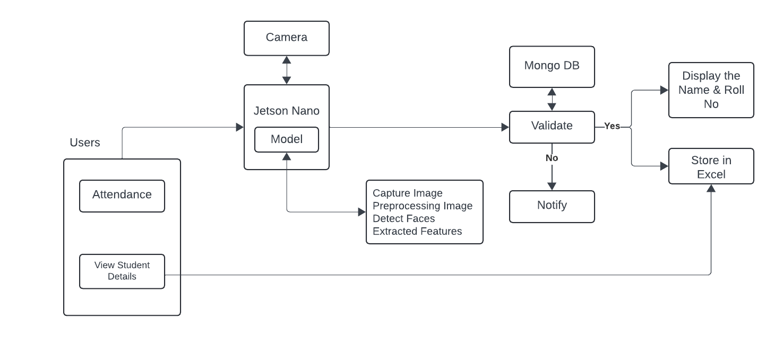

Fig 3.1 Architecture Diagram

Hence, the communication between the hardware (Jetson Nano) and software (Python, Flask, OpenCV) is critical for real-time processing and data storage. The system designed must provide scalability and efficient latency for face detection along with updated attendance records. One type of client-server model is being followed: where facial recognition tasks take place in the edge device Jetson Nano while the backend server contains attendance records, with this being accompanied by a web interface built with Flask that provides real time reporting ability.

**3.3. DATA COLLECTION AND PREPROCESSING**

Every facial recognition system is based on the concept of data collection. For this project, photographs of students’ faces are gathered. These photographs are taken at several angles, under different lighting conditions and with a range of facial expression 3.1. This helps in making the dataset reusable and up to the required standard. The richness in the dataset ensures that any system works very well even in real conditions, as long as environmental variation changes.

|  |  |  |
| --- | --- | --- |
| **Front View** | **Left View** | **Right View** |
|  |  |  |
| **Mask View** | **Specs View** | **Mask & Specs View** |
|  |  |  |

Table 3.1 Different views of data

Preprocessing is an important step before training the facial recognition model for that we did all different views as shown in fig.3.1. The images are resized to a fixed resolution suitable for training after which the methods applied include face alignment and image normalization to enhance data quality. Face alignment ensures that important facial region features-the eyes, nose, and mouth-are aligned correctly, thus enhancing correct recognition. In addition to this, noise removal from images 3.2 is also a part of the preprocessing step. Minimum effect of poor lighting and background interference can be attained through filters. Preprocessed data divides the dataset into training and testing sets and makes sure that enough data has been fed into the model so that it could be tested against. Data augmentation is also applied to improve the facial recognition system's performance. This technique creates extra training data by simply modifying small points of the original images-for example, rotation, flip, and slight modification in the lighting conditions. This makes sure that it generalizes well for unseen images and increases accuracy, hence, it is good.

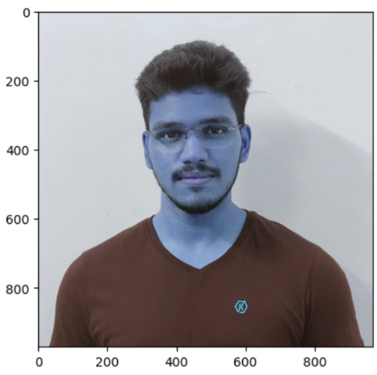 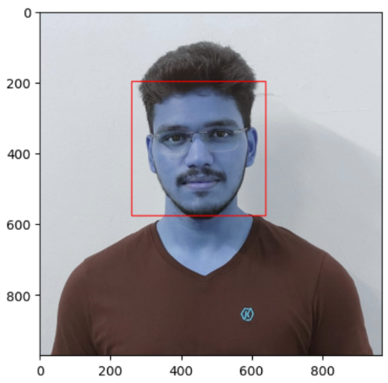 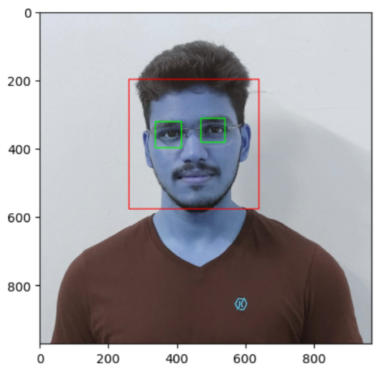

Fig 3.2 Feature Collection & Extraction of data

**3.4. FACE DETECTION ALGORITHM IMPLEMENTATION**

During face detection algorithms, a face will exist in the captured frames of video. For this project, we used OpenCV and implemented the Haar Cascade Classifiers - an algorithm very highly used in real-time face detection. How does it work? Well, basically, a Haar Cascade is a pre-trained model that detects the features of a face: the shape of eyes, nose, mouth, etc. The Haar Cascade algorithm processes each frame and scans the frame for a pattern that would match with the predetermined facial features. It then results in an output, which is a bounding box that encloses the face detected. This bounding box crops the face from the image and prepares it for further processing by the facial recognition algorithm. The first motivation to

use Haar Cascades for face detection is its efficiency and relatively lightweight design, suitable for real-time deployment on such edge devices as Jetson Nano. Besides this, there could be hundreds of detections within one frame in the classroom scenario with many students as shown in fig.3.3. Though Haar Cascades provide fast detection, they suffer at light and angular changes. Thus, with these constraints in place, further processing steps like histogram equalization are carried out in order to make the images better contrasted and hence improving the robustness of the techniques of detection.

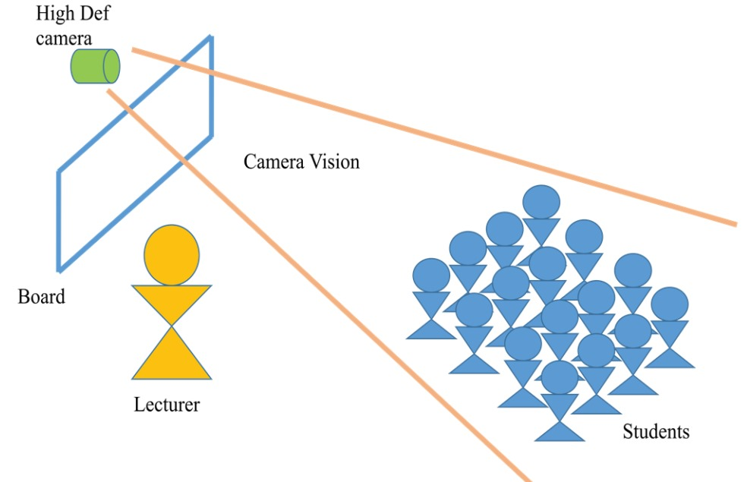

Fig 3.3 Camera Arrangement in a classroom

**3.5. FACIAL RECOGNITION AND ENCODING PROCESS**

The essence of an attendance system is based on facial recognition: the captured pictures are compared to the database of faces initially registered. Encoding facial features, using algorithms of deep learning algorithms like FaceNet or Dlib 3.4, converts a detected face into vectors with a size of 128 dimensions. It generates a vector, or face embedding in it, while using a pre-trained Convolutional Neural Network optimized for facial recognition tasks. All students' faces are encoded and stored in the database. With the new face detected, an encoding of the new face is generated and then compared with all the ones stored in the database. A match is determined according to a preset threshold which in most cases is Euclidean distance, the system identifies the student’s presence, that is it marks the attendance of the student. Advanced deep learning techniques like FaceNet work to ensure that facial expressions, light, and angles variations are taken care of to reduce both false acceptance and false rejection rates.

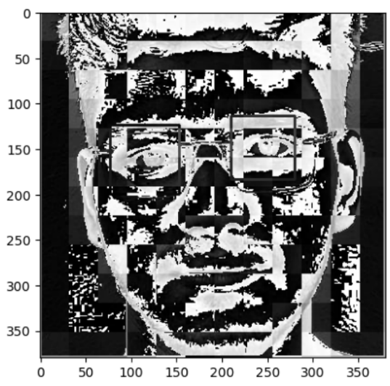

Fig 3.4 Face Encoding Image

**3.6. INTEGRATION WITH JETSON NANO FOR EDGE COMPUTING**

The Jetson Nano is the primary device that is utilized for implementation of the facial recognition algorithms. An edge device known as the Jetson Nano, allows running of machine learning models on the device itself. This reduces the chances of making constant calls to a cloud server. Therefore, it also helps in reducing the latency. It is due to the GPU acceleration capability of Jetson Nano that it can work with real-time processing of complex image tasks. The facial recognition model is deployed on the Nano, and therefore, the system can now right away start processing video feeds from the camera. So, it could run adequately without good internet connectivity. It is also scalable for any system using Jetson Nano. Because the device is cheap and portable, many classrooms or even whole campuses can be covered by a decentralized network of attendance systems without much overhead cost.

**3.7. DATABASE DESIGN AND MANAGEMENT FOR ATTENDANCE RECORDS**

It requires an efficient backend database for storing attendance records. For this project, we have used MySQL in order to manage the attendance data. The database is designed to store information such as names of the students, roll numbers, facial encodings, timestamp and status of attendance. Summarizing it all, we have utilized the following key tables in our database schema.

* Students – This table holds some basic details of each student, viz roll number and name.

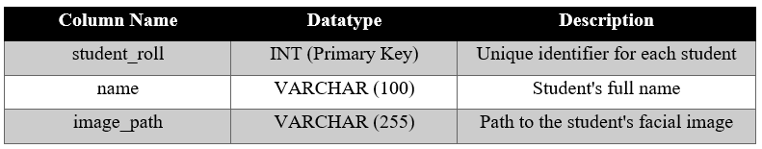

Table 3.2 MySQL Table for student

* Attendance – this recorded attendance in the table allows for filling in date, time, and the roll number of students. It includes an additional timestamp when attendance is marked.

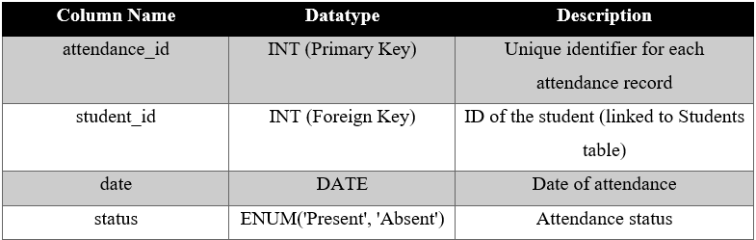

Table 3.3 MySQL Table for Teacher

The database is connected to the facial recognition system through Flask APIs, thus allowing real-time updates to the attendance records as soon as students are recognized. Teachers can obtain access to attendance data through a web interface where they might print the report or see the attendance trend.

**3.8. REAL-TIME ATTENDENCE MARKING WORKFLOW**

Upon identifying a student’s face, the system instantly enters the corresponding student’s attendance into the MySQL data storage. The sequence of this process is detailed below:

1. A camera is used to record students entering the lecture hall.
2. The face recognition algorithm detects the faces in the video.
3. The identified faces are cut out and entered in the recognition system which searches them against the database.
4. The moment a face is identified, attendance of the said student is marked within a few seconds and current time is noted.5. The attendance details are modified in the records kept in the system. The system, however, does not stop there and continues scanning the classroom for more students for additional records.

This automated outfitting of the system allows for the marking of attendance – swiftly and accurately – with no manual or physical involvement from either educators or the students.

**3.9. HANDLING ENVIRONMENTAL VARIATIONS**

One of the main obstacles that most facial recognition systems face is the variation of the environmental conditions like lighting and angle as shown in fig.3.3. It should be pointed out that weak lighting conditions or extreme angles may lower the detection and recognition accuracy of faces. Some techniques have been employed to deal with the aforementioned problems:

1. Histogram equalization provides enhanced contrast in images and thus can favour the low light conditions for more reliable face detection.
2. Augmented training data, which includes photographs taken under various lighting conditions, will help the model in achieving that goal of performance due to the proper and analogous variation in the environment.
3. In the case of angles, the alignment techniques are applied to rotate the detected face to standard orientation before recognition [9].

All these measures will help the system to perform correctly in a variety of classroom environments.

**3.10. TESTING, VALIDATION AND ACCURACY EVALUATION**

To be sure of the system's efficiency, it is tested and validated based on various conditions. The system is tested in different classrooms with varying numbers of students, lighting conditions, and angles. In achieving accuracy regarding recording of the system, a comparison is also done against manually marked attendance in class.

**CHAPTER 4**

**SYSTEM DESIGN**

It forms the design of the system in which hardware and software components make a harmony of results such that data exchange is always smooth. This section states the hardware configuration setup and the architecture of software required to develop a state-of-the-art attendance management system using facial recognition technology.

**4.1. OVERVIEW OF SYSTEM DESIGN**

Generally, the system design of the Smart Attendance System With Real-Time Facial Recognition Using Jetson Nano comprises two major components: hardware and software. From the hardware end, fitting devices in processing and data capture may include Jetson Nano and camera with a high resolution, while the software architecture integrates all kinds of algorithms and frameworks, such as libraries in Python, which will be used in machine learning and image processing. This combination promotes the achievement of effective facial recognition and real-time attendance management to ensure that the system works correctly and effectively in a variety of environments while minimizing administrative burdens on educational institutions.

**4.2. HARDWARE CONFIGURATION**

It is highly essential that the hardware configuration of the Smart Attendance System With Real-Time Facial Recognition Using Jetson Nano should be appropriately configured to achieve efficient functionality and not to develop fault. The following are the hardware components that are primary in integration which include the processing unit as Jetson Nano, the camera module for image capture, and the SD card setup as shown in the subsequent points.

**4.2.1. Jetson Nano as Processing Unit**

The Jetson Nano is the central processing unit for this facial recognition system; it was chosen for its excellent balance of computing power and energy efficiency. The Jetson Nano is the small yet very powerful AI computer designed to run deep learning applications. Real-time image processing, which is pivotal in the recognition of students in a classroom, can be efficiently made possible with the GPU acceleration from the Jetson Nano. Specifications:

1. CPU: Quad-core ARM Cortex-A57
2. GPU: Comprising of 128 CUDA units, widely used for manipulation which results in faster execution of extensive processes owing its abilities for parallel processing.
3. Memory: 4 GB Of LDDR4 RAM facilitates thousands of active applications with no performance degradation.
4. Storage: 16 GB eMMC with microSD card slot available for internal use; this contains sufficient room for growth already including the facial recognition systems data, other programs and materials.

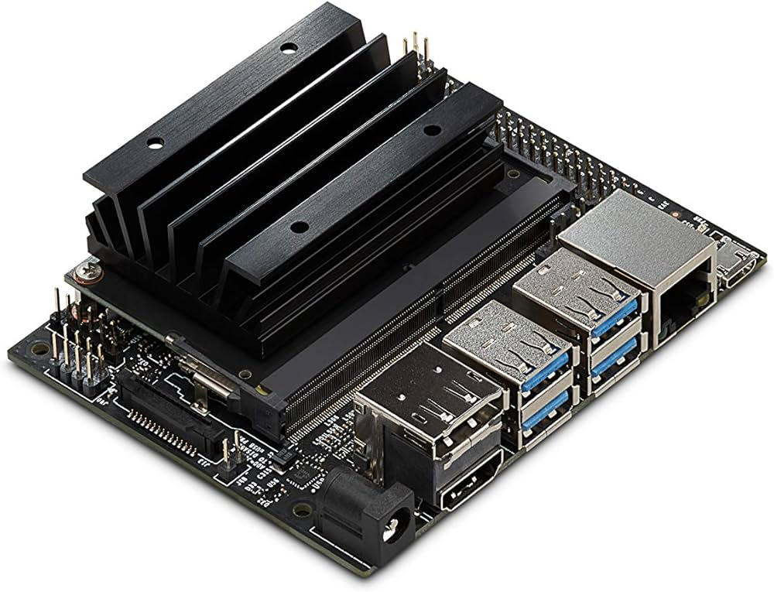

Fig 4.1 Jetson Nano

Such specifications, therefore, makes it possible for the Jetson Nano to undertake tasks that require significant computational capabilities making it suitable for applications that require real-time input and processing.

**4.2.2. Camera Module**

A camera module captures images of students upon entry and plays a very critical role in the Smart Attendance System With Real-Time Facial Recognition Using Jetson Nano. The quality of images captured would determine the effectiveness of facial recognition; thus, proper camera modules are very important in this system. Features:

* + Resolution: The camera resolution should be at least 1080p to display clear facial images. More pixels is acceptable since that obviously would mean higher accuracy in recognition because of the capacity to capture more face details for an analysis.
  + Field of view: The field of view of the camera must be wide enough to capture several faces within the frame simultaneously. It can focus on numerous faces in a classroom if several students enter at once.
  + Frame Rate: The minimum frame rate required for a smooth video capture would be 30 frames per second. This will ensure that the algorithms have a sufficient number of data points to work with, rather than missing students that swiftly enter the room.

It can do so by incorporating a quality camera module and in so doing, give the system high accuracy in the identification of the students as well as recording of attendance.

**4.2.3. SD Card Setup**

In this case, Jetson Nano uses a microSD card to store its operating system and applications that enable the running of facial recognition software. Format and flash the SD card correctly for the system to work properly.

**4.2.3.1. SD Card Formatter**

Before applying a microSD card, it needs to be formatted to be ready for the Jetson Nano. To prepare it, a suitable utility like SD Card Formatter erases all the data present and sets up the file system. Proper formatting is important because an erroneous formatting of the card would probably lead to boot failures or instability in systems. The following outlines the steps.

1. Obtain and configure the Appropriate SD Card Formatting Software.
2. Position a microSD card into the card holder.
3. Launch the SD Card Formatter application and identify and highlight the correct drive assigned to the microSD card that was just inserted.
4. Just select Quick Format and allow the application to format the card.  
   The microSD card is now wiped clean, hence it has to be prepared for flashing an image for Jetson Nano.

**4.2.3.2. Flashing the SD Card**

In order to get the operating system installed on the Jetson Nano, it becomes imperative to flash the SD card with the correct image. Balena.io is a good option for all users since it facilitates this process and much more. In order to ensure proper execution of an installation, it is necessary to adhere to the following procedure:

1. Download the SD Card Image for the Jetson Nano JP461:
   * The first step is to go to the official NVIDIA website and download the newest Jetson Nano JP461 SD card image. The image above demonstrates the operating system that is most appropriate for Jetson Nanos, as well as other essential applications, useful in the course of Jetson Nano operations.
2. Flashing the SD card using Balena.io:
   * At this step, you should visit www.balena.io and get the Balena Etcher program designed for deploying images to memory sticks. When this is done, install the software on your machine.
   * Once the application is online, open Balena and locate the jetson nano image that was previously downloaded.
   * Select the appropriate microSD card that has been formatted and will serve as the image target.
   * Lastly, press the Flash button to complete this action. Balena Elliot will then proceed to write the image into the microSD card and make it ready for the next use.
3. Install and Turn On:

* Once the process of flashing has been performed without incident, kindly make sure you eject the microSD card safely from the system.
* Otherwise, the microSD card that has been previously flashed will be inserted to Jetson Nano.
* Next, plug in the power supply unit into the Jetson Nano and switch it on.

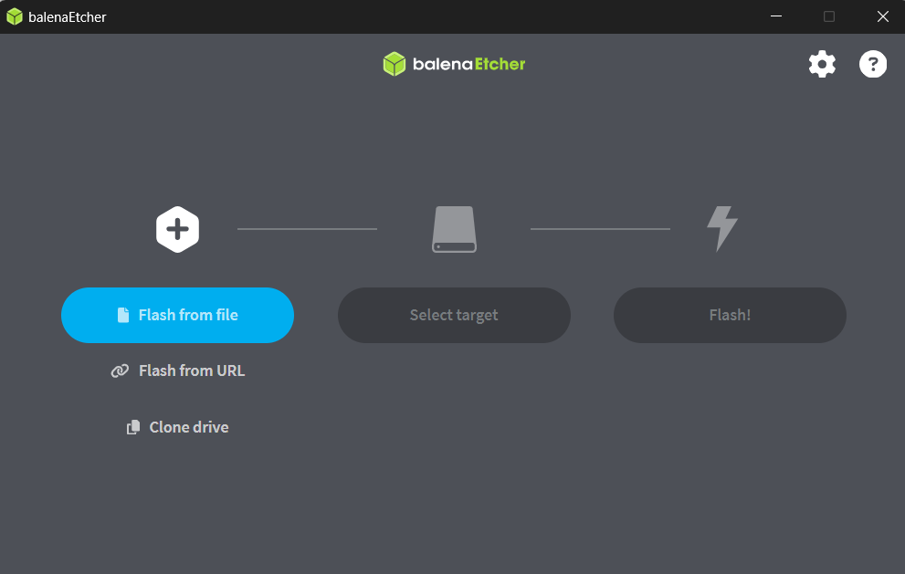

Fig 4.2 Flashing the Jetson Nano img into SD Card using balenaEtcher

Upon performing the aforementioned procedures, the Jetson Nano will be able to start up using the microSD card and the operating system will be in place ready to be reconfigured and integrated with the facial recognition software. This installation guide is also very important because it helps to ensure that the hardware is correctly set, which enables running the required programs efficiently.

**4.3. SOFTWARE ARCHITECTURE**

The structure of this Face Recognition Based Attendance Management System consists of various elements which function together for efficient management and end user interaction. This architecture includes the operating systems, programming languages, libraries, frameworks and algorithms of the entire system.

**4.3.1. Operating System**

The structure of this Face Recognition Based Attendance Management System consists of various elements which function together for efficient management and end user interaction. This architecture includes the operating systems, programming languages, libraries, frameworks and algorithms of the entire system.

The operating system is essential for the proper working of the Jetson Nano when working on machine learning and image processing applications. In this project, the OS that is recommended is an Ubuntu-based OS, namely:

* Ubuntu 18.04 LTS: this version is quite advantageous for the Jetson Nano since it is a long support edition providing stability in operations as well as regular upgrades. Ubuntu 18.04 LTS has its own software packages making the work of installing and managing the necessary Libraries and Tools for the projects easy. The robust and resource effective design of the architecture is a great advantage since the project involves heavy tasks such as facial recognition.

**4.3.2. Programming Languages**

The main coding language applied in the creation of the Smart Attendance System With Real-Time Facial Recognition Using Jetson Nano is Python. This language is in great demand, particularly for this project, due to its easy-to-read structure and availability of lots of machine learning and computer vision libraries. Python Libraries:

* OpenCV: An Image Processing Library. This library is essential for face detection, recognition, and manipulation of an image. OpenCV features a large set of tools and functions that efficiently carry out all the image handling in order to implement complex algorithms with ease.
* face_recognition: Creates an implementation of the face recognition algorithm. This is a library built on top of dlib, and there are quite user-friendly functions by which faces shall be recognized and processed in images. With a very straightforward API, the integration into the system will be quick, and thus gaining accurate facial recognition with minimal development effort.

**4.3.3. Software Components**

The software structure is composed of a number of essential elements necessary for the operation of the attendance management system. This consists of the face recognition algorithms and the web interface.

**4.3.3.1. Facial Recognition Algorithms**

In the current attendance management system, facial recognition capabilities serve as the heart of it. This work based on several algorithms effective in recognizing students accurately. Included among these are:

* CNNs: CNNs are widely used for feature extraction as well as classification in the facial recognition pipeline. Ideally, they are very apt for images since these learn hierarchical feature representations for image inputs and identify fine patterns present in facial data. Thus, the actual implementation of CNNs improves precision and effectiveness in the recognition process so that a person is recognized with great accuracy.
* Haar Cascades: Primarily, the detection algorithm used is Haar Cascades. With the help of these, the system will be able to detect faces in real-time. In implementing Haar Cascades, a set of features from the training data is utilized for efficient face detection in images. Though it would not be as sensitive as other algorithms, with regard to real-time applications, it is considered very efficient. In this aspect, the speed and efficiency of the attendance management system pave the way toward fast and accurate detection of students entering the classroom.

**4.3.3.2. Web Frameworks**

In order to develop an easy to operate system for managing attendance records, Flask is adapted as a web framework. Flask acts as a center core penetration of the application helping in performing the communication activity for the web application between the front and back end of the application. Here are the Flask Features:

* Lightweight and Easy to Deploy: Flask is pretty famous for the minimalist; therefore, it quite simple to get it up and running and deployed. It is lightweight in nature, which allows the developers to do all the core functionality coding instead of dealing with overhead.
* Backs development in RESTful API: Flask supports the development in RESTful APIs. Within this application, we are going to use RESTful APIs to tell the frontend system of the application how it needs to communicate with the backend system. This will, therefore, allow educators for real-time data, proper management of attendance records, and even smoother interactions with the facial recognition system.

**4.4. DATABASE DESIGN AND MANAGEMENT**

The Smart Attendance System With Real-Time Facial Recognition Using Jetson Nano consists of a database which is a very crucial aspect of any system and attendance management in particular. It aims at making sure that all attendance details are safely kept, easily accessed, and managed without much stress. This part explains the database structure design and the management practices that are put in place in addressing preservation of data and ease of access in regards to the database.

**4.4.1. Database Selection**

MySQL is selected as the Database Management System for the Smart Attendance System With Real-Time Facial Recognition Using Jetson Nano because it performs well, scales, and works effectively with Python. Furthermore, MySQL is common in any web-based applications, which implies that it will be able to manage the attendance records effectively. Reasons for Choosing MySQL:

* Open Source: MySQL can be accessed easily for usage and support from other external parties is very easy which makes it cost effective for learning projects.
* Scalability: It can accommodate an increasing number of records due to an increase in the number of students and also attendance data.
* Reliability: MySQL is able to maintain a high level of data consistency and integrity thereby ensuring that attendance records are kept in the right manner.

**4.4.2. Database Scheme Design**

The layout of the database is created not only to keep attendance which is the focus but also to provide appropriate relationships between various entities Сore – primary tables of the database are:

* Students Table: This table holds the details of students containing details such as their identification numbers, the names of the students and photos of students for facial recognition.

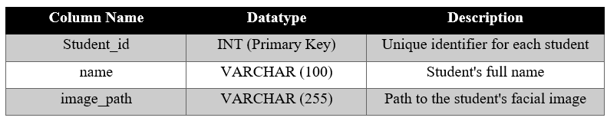

Table 4.1 Student Information Table Structure

* Attendance Table: This table contains the records of the attendance entry whereby the students are linked to a particular attendance status for a certain date.

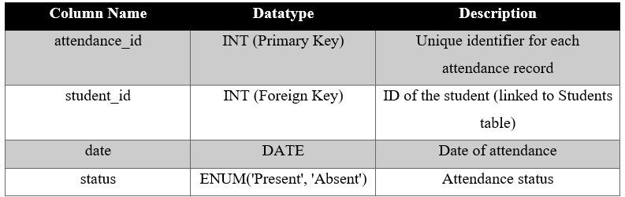

Table 4.2 Teacher Information Table Structure

**4.4.3. Data Management Strategies**

To maintain the integrity and accessibility of the database, several management strategies are implemented:

* CRUD Operations The system shall enable Create, Read, Update, and Delete (CRUD) operations to appropriately manage attendance records. The educators will be able to input new records, find the current status of attendance status, update some records when changes are needed, or delete old ones.
* Data Backup and Recovery: Backing up databases on a regular basis helps avert the risk of losing data due to malfunctioning devices or damaged data. MySQL provides different options for backing up databases such as mysqldump logical backups and physical backups of the database program and files from the hard drive.
* Safety of student records: In this way, data security is applied to make certain that no details pertaining to any of the student’s records can be accessed in any way. To this end, limited access to the system is made possible by insuring use of hard-to-guess passwords, encrypting all sensitive data and implementing user role access to sensitive operations.

**4.5. INTEGRATION WITH JETSON NANO FOR EDGE COMPUTING**

The software component integration with the Jetson Nano provides a platform for developing real-time facial recognition and attendance management systems. This section reviews the configuration and integration techniques used for effective utilization of the Jetson Nano computing resources.

**4.5.1 Jetson Nano Configuration**

In order to boost the efficacy of the use of facial recognition system on the Jetson Nano appropriate configurations and optimization must be done. Jetson Nano can support multi-tasking, thus, suitable to run image processing and database includes operations at the same times.

* Resource Allocation: Adjusting the Jetson Nano to effective resource allocation helps in optimizing the use of the CPU and the GPU. This entails modifying certain parameters like memory management and task scheduling and allowing some processes like face recognition to have more control during execution.
* Install Necessary Packages: It is also important to note that several core packages also dependencies need to be incorporated into the system for its possible operation. For instance, it will be necessary to include libraries such OpenCV, face_recognition, Flask and the MySQL connector for Python. Such packages come by default with the operating system but it’s advisable to install the latest version through a package manager.

**4.5.2. Data Flow Architecture**

Data flow architecture describes how data is transferred from one component of the system to another. This data flow can be summarized in the following sections:

* Data Capture: The Camera module in the system takes pictures of each student coming into the class and sends the images to Jetson Nano board for processing.
* Face Detection and Recognition: The pictures obtained are then analyzed according to the preset algorithms to carry out face detection and recognition (CNN and Haar Cascades). In case an appropriate image of the student is found, his or her identification number is retrieved from the database containing students information.
* Attendance Marking: After a student has been identified, their particulars are then marked as present or absent in the Attendance table. This entails changing the current date and the status to present or absent in the database.
* Data Presentation: The attendance data is also made available to educators through the Flask web interface which is connected to a MySQL database and is capable of displaying the data in a simple and easily digestible manner.

**4.5.3. Performance Optimization Techniques**

In the way that makes sure the Jetson Nano system operates correctly at its optimal performance limit, the following optimization techniques have been integrated in this manner.

* Batch Processing: Instead of processing one image after another, it is possible to process a set of images simultaneously using mechanisms available in batch processing, hence, lag will be significantly minimized.
* Model Optimization: By employing practices like transfer learning for model pruning or quantization of model weights, it is possible to create smaller machine learning models that can have better speeds on inference while retaining the same level of performance.
* Efficient Resource Management: The application will make it possible to monitor the performance of Jetson Nano and make the necessary adjustments instantly. For instance, NVIDIA’s Jetson System Profiler assists in checking what resources are busy and what resources are causing a bottleneck.

**CHAPTER 5**

**RESULTS AND DISCUSSION**

**5.1. FLOW CHART ANALYSIS OF SYSTEM WORKFLOW**

From the flowchart, it is therefore clear that the whole system operates from detection of students to when attendance is taken. It outline the step by step procedure showing procedures from face detection all through to recognition, comparison, and data storage. This cay of graphical flow turns out useful in an attempt to make it easier to understand how the system actually works and how all its components are put together in order to provide seamless attendance experiences. Workflow initialization: The system initializes the Jetson Nano and camera module. It continuously detects whenever faces enter the frame. Whenever a face is detected, it captures the image and makes a process through a facial recognition model that is preloaded. In case of successful recognition, the student record is fetched from the database linked to it, and attendance is marked. If recognition fails, then the image is discarded, and the system goes into monitoring for new faces. Flowchart simplification of such an intricate process makes it easy for troubleshooting and optimizing performance.

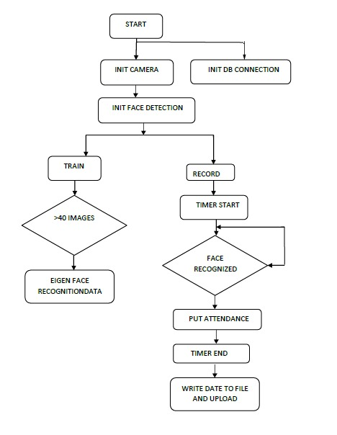

Fig 5.1 Flow Chart of System Workflow

**5.2. IMAGE SEGMENTATION: EQUALLY SIZED CELLS AND FACE DETECTION**

The captured images are divided into cells of about the same size for accurate face detection. This way, different cells in the same captured image can be processed so that facial features are not missed regardless of their location within the frame. This manages the situations in which more than one face fits into the same frame, especially crowded rooms such as classes where many students sit within the frame. The splitting of the image into smaller parts makes it easier to analyze and eventually minimizes chances of missing faces during the detection.

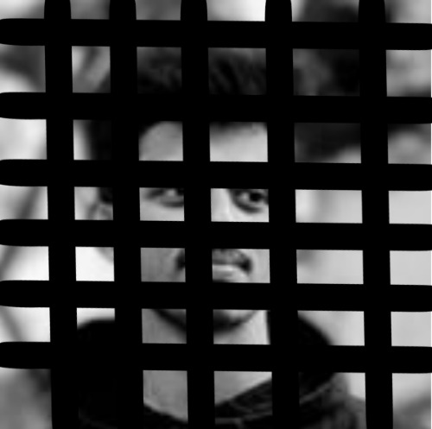

Fig 5.2 Segmented Image

Furthermore, this technique reduces computing cost and processing load, enabling the Jetson Nano to analyze several individuals’ faces simultaneously. Because smaller areas are focused on, the system is able to pick up faces that are obscured or partly covered, which would otherwise be impossible in large scale image processing. Since segmentation assures the full area of the frame is covered, the effect is positive on the system in terms of detection accuracy and reliability.

**5.3. THRESHOLD VALUE CALCULATION FOR RECOGNITION**

The threshold value calculation is an important part of the recognition process. In this system, a threshold value is calculated that determines the similarity between the input facial image and the stored images in the database. If it finds the similarity score exceeds the threshold, the system confirms a match and marks attendance.

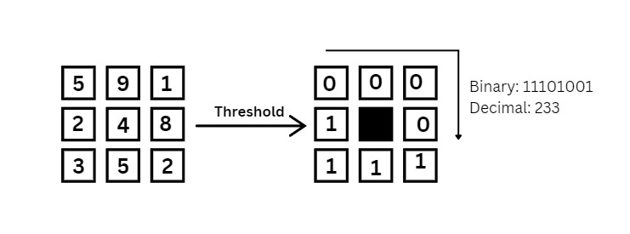

Fig 5.3 Threshold of centered pixel 4

There are multiple test cases in which threshold has been adjusted, considering the lighting condition and facial angle and occlusion. The degree to which the threshold can be adjusted could provide a good balance between false positives and false negatives, maintaining a much higher degree of accuracy even with partially occluded faces or at odd angles. Testing was done by checking the threshold values under different settings to arrive at the best value. The validation was rigorous, where the system's performance is taken in terms of real-world datasets. This further revealed that fine-tuning the threshold can enhance recognition accuracy with a reduction in errors primarily under adverse environmental conditions.

**5.4. FLASK INTERFACE: REAL-TIME RESULTS ANS SYSTEM INSTRUCTIONS**

The web-based interface provides an interactive and friendly interface for administrators or teachers to interact with the system; thus, there is real-time access into attendance records and other system metrics. After the system has successfully detected and recognized a face, the Flask interface instantly updates the attendance database, visible to the user. The interface provides instructions on how to run the system and outputs real-time attendance results, including steps on how to initialize the camera, how to manage database records, and how to troubleshoot frequent problems. Flask's lightweight structure means the web interface will be highly responsive even when running under high-load conditions where multiple faces are continually detected one after the other.

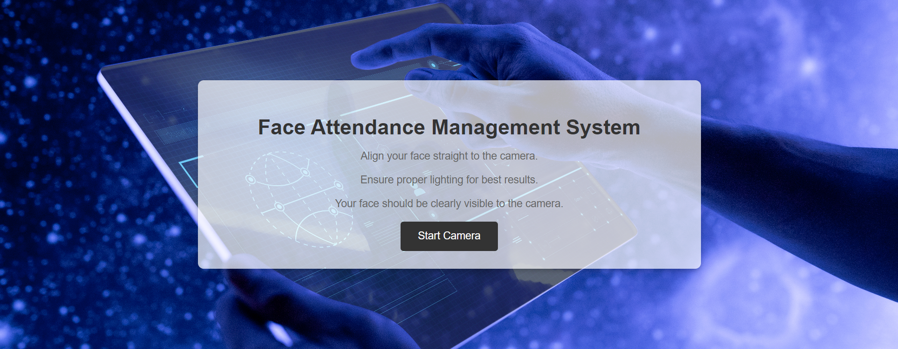

Fig 5.4 Image of Frontend using Flask – Instruction Page

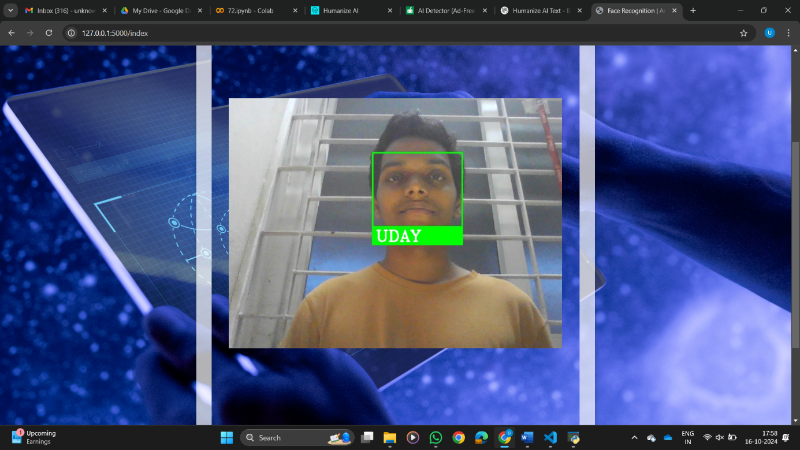

Fig 5.5 Image Capturing using OpenCV

Screenshots (Fig.5.4, Fig.5.5) of the Flask interface indicate a well-balanced simplicity and effectiveness at its design. It uses a clean layout supplemented with real-time data visualization, making it extremely easy to use for users with little or no need for technical knowledge in managing their everyday attendance records. The framework also supports RESTful API capabilities so that integration with other school management systems may be performed if it is needed.

**5.5. FACIAL LANDMARKING: NODAL POINTS AND EYE ANGLE DETECTION**

Landmarking face is a crucial part of the identification process. The system identifies major nodal points on faces -like eyes and nose's corners and the corners of the mouth. The nodal points are used to form a distinctive facial signature. This signature is then matched against the database records while identifying the person. Finding and analyzing such nodal points ensure that the system captures significant facial features, even if the person's face is tilted or partly covered up.

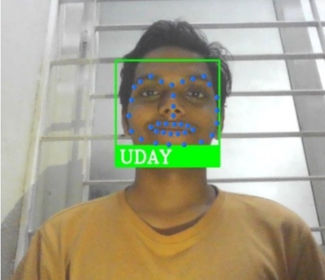

Fig 5.6 Nodal Points on face

Eye-angle detection is another, but this feature is important when you capture faces from different angles. This is because the eye positions and others are used to compensate for distortions caused by facial tilt, so the system can achieve an accurate recognition even when students are not facing the camera head-on. The nodal mapping technique compensates for slight movements of the face so expressions or slight changes in posture do not affect recognition performance.

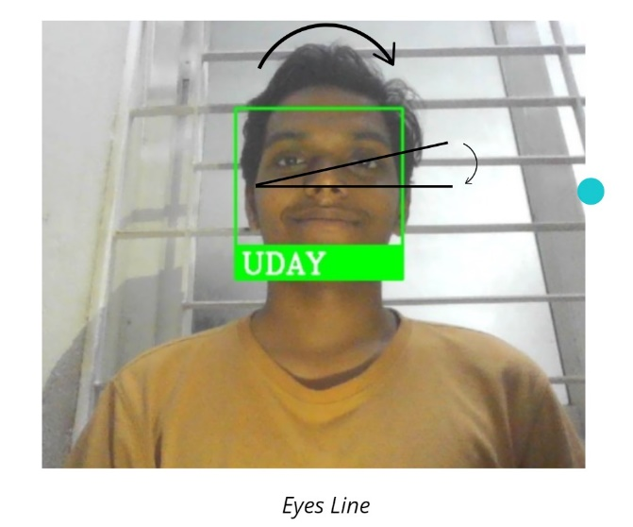

Fig 5.7 Angle between Eyes and Nose

**5.6. DATABASE MANAGEMENT AND ATTENDENCE RECORDS**

The database forms the backbone of this system in that it is where all the data on facial recognition and attendance is kept. Once a student’s facial features have been encoded, the vector together with his or her other properties is kept in the database. The vector of a newly captured image is matched with stored images to identify the student and to mark attendance.

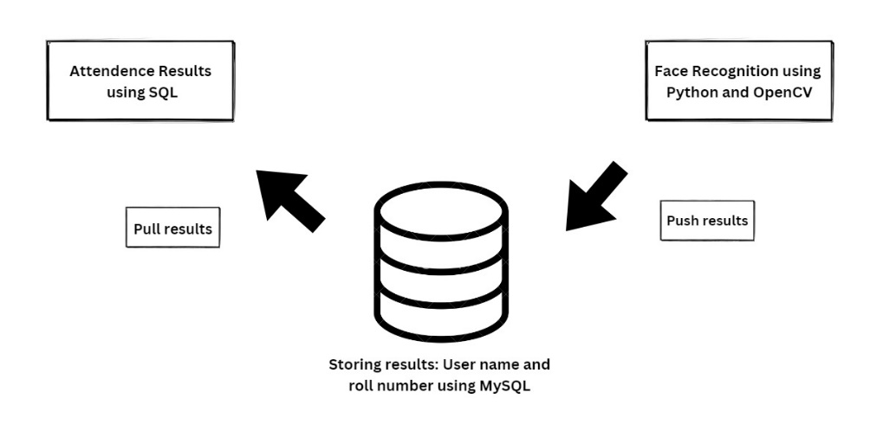

Fig 5.8 Connection between the recognition and attendance management systems

Database management addresses speed and accuracy with careful consideration. The system employs indexing strategies in order to enable fast access to data when needed during recognition. The problems of performance degradation cannot be suffered even as more students are added to the database and the efficient storage techniques come in. Moreover, the system allows the attendance records to be updated directly at the moment of their creation, so that the current information can always be available to the administration. The structure also allows for easy retrieval of such data for the past, enabling the educators to monitor the attendance patterns over the years. Attendance records are stored in excel sheet as shown in Fig.5.9.

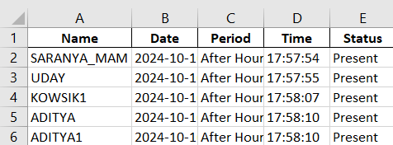

Fig 5.9 Attendance Records stored in Excel sheet

**5.7. REAL TIME PROCESSING: FRAMES PER SECOND (FPS) ANALYSIS**

In respect to system performance, real time processing is very crucial especially in places where there are many people, for example, classes. The frame per second (FPS) rate of the system defines its capacity to process and recognize faces in real time. Faster FPS rates means that the video capture is more fluid and the system can accommodate many faces without any delay.

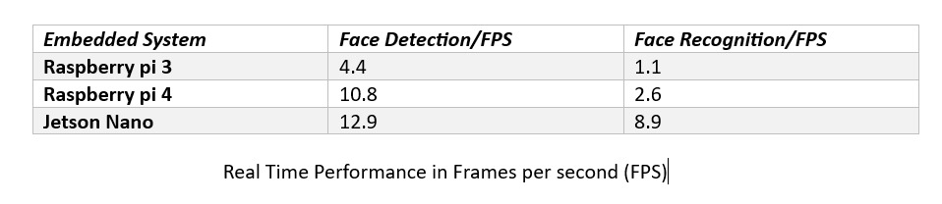

Fig 5.10 Real time performance in Frames Per Second

During the tests, the optimal FPS performance was calculated under certain amounts of light and different numbers of people present in the picture. The study found that the Jetson Nano could barely reach 15-30 FPS depending on the scene's difficulty. Due to the system's capacity to work effectively at high FPS rates, it is possible to conclude that the system is capable of operation in environments with intense movement of students within the detection zone.

**5.8. COMPARISION OF BIOMETRICS MODALITIES**

The study also sought to measure the effectiveness of the facial recognition system upgrade by assessing performance against the facial, voice, iris and retina biometrics recognition technologies. Each one of these modalities has its advantages and drawbacks, although the facial recognition technology was selected for this project because of its less intrusive nature and simple usage in the classroom.

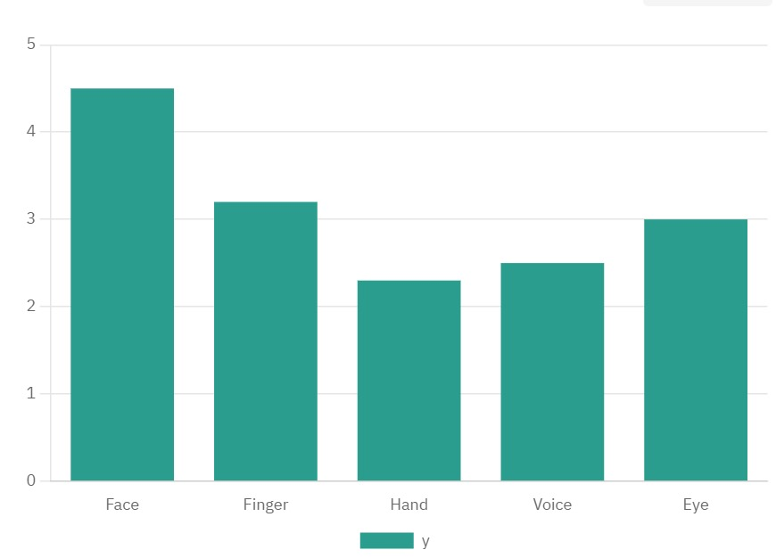

Fig 5.11 Biometric Modalities Comparison

The comparison was illustrated by the use of a bar graph aiding visually in distinguishing the differences in the levels accuracy and processing speed as well as the usability of these modalities. As usage of face recognition was more convenient, in that it did not even require the user to come into contact with any device, the users’ perspective was the most favorable towards it. However, iris and retina cameras achieved these results only when the users were registered in a special room that had advanced equipment.

**CHAPTER 6**

**CONCLUSION AND FUTURE WORK**

With the Jetson Nano, this developed system for facial recognition-based attendance management is just outstanding in the automation of tracking the attendance of students in educational environments. The result of an innovative solution integrating advanced technology in facial recognition, efficient software architecture, and robust hardware components was successfully implemented to create a reliable and effective solution for both educators and students.

**6.1. CONCLUSION**

The project aimed at making the attendance management streamlined by reducing time and effort spent when tracked manually while enhancing accuracy and reliability. Conventional attendance systems often rely on manual processes that may be time-consuming and hence prone to human error. The live identification of students is carried out through facial recognition technology, and the system automatically marks attendance when the students enter the classroom. This saves the time factor while also reducing the incidence of errors allied with manual entry.

The Jetson Nano was chosen as the processing unit. It has been turned out very useful in developing this application due to the highly capable GPUs that make possible the real-time image processing and the execution of machine learning algorithms. In this system, major libraries like OpenCV and face_recognition are used. This simplifies the easy implementation of image processing operations like face detection and recognition. Flask as the web framework is integrated into this application and makes it somewhat friendly to the educators by ease accessibility of data and viewing is quite handy.

In addition, the MySQL database will be essential for providing an organized attendance record. This would help data to be stored correctly and retrieved instantly. Implementing CRUD operations basically enables educators to update their attendance records dynamically in real time. The dynamic interaction between the software and hardware ensures a smooth user experience as well as a high degree of operational efficiency.

**6.2. FURTHER WORK**

While the Smart Attendance System With Real-Time Facial Recognition Using Jetson Nano is working and efficient nicely, there are a number of scopes left open for future work that could refine its capabilities and applicability:

* Teacher Mobile App: This customized mobile app can be developed, where teachers will be able to click the photo of a class directly with the help of their cell phones. This specific photo will be sent to the back-end where face recognition algorithm will process it so that automatically that particular attendance and records it. Depending on that, feedback about the live status of attendance can be sent, and also it can update through the connected web interface.
* Interface with Web Interface: All backend processing from the mobile application is then integrated with the existing attendance web page. That is, attendance records will be automatically updated on the web portal where it will be analyzed and managed by the concerned educators. Such a web interface can also offer the facility of manual correction or crosschecking to avoid errors.
* Scalability: If this system were ever to be scaled up with an education institution, the system should be able to accommodate more students. Subsequent incarnations could implement the use of remotely hosted databases to mitigate the data overflow issue and enhance accessibility to the stored data.
* Multi Factor Authentication: There are also possibilities of addressing the security and correctness concerns through the introduction of multi factor authentication where a biometric finger print or an ID card scan will be incorporated. This would serve as an additional confirmation that attendance records in question can be relied upon as strike-proof.
* Enhanced Adaptation to the Surroundings: There exists a potential of optimizing the system’s functionality where there is a need for increased adaptability to environmental great variance such as varying lighting conditions and angles of view. There are instances when image enhancement techniques such as adaptive histogram equalization come in handy when the lighting is poor and a clear image is required.
* Mobile Application Development: A mobile application for teachers and students would facilitate engaging with the attendance system more effectively. Possible features to be included can be notifications on their attendance or a portal for the students to check their attended classes via previous attendance records.
* Integration with Learning Management Systems (LMS): Incorporating an attendance management system within the existing learning management system software’s, would allow for real-time maintenance of attendance records as part of an integrated service offer for education providers thereby reducing administrative work further.
* Analytics and reporting: Analytics and reporting can further be entertained in the attendance system by integrating the functionalities to provide other analysis or reports pertaining to the attendance eg attendance pattern analysis. This will enable educators in identifying trends and areas that require improvement hence making them to be able to make sound decisions basing on data.

**6.3. FINAL THOUGHTS**

Therefore, the Smart Attendance System With Real-Time Facial Recognition Using Jetson Nano developed can create the opportunity of bringing state-of-the-art technology in school campuses to allow enhanced efficiency in the management of daily operations. Although the current deployment is highly helpful, it will also involve various emerging challenges that will need to be managed by continued development and refinement over time. Embracing the full potential of technological advancement and responding to user needs can make this project the complete attendance management solution adapted to the dynamic necessities of modern schools.

**REFERENCES**

1. Dennis Joshua D, Ganesh Kumar Chellamani, Manoj Prabhakaran K, Yaythish

Kannaa G S, “*CrackVision: A Fusion of Deep Learning and Image Processing for Comprehensive Wall Crack Detection and Analysis*” 3rd AIIoT Conference, Vellore, pp. 1-5, DOI: doi.org/10.1109/AIIoT58432.2024.10574570, 2024.

1. Bao-Thien Nguyen-Tat, Minh-Quoc Bui, Vuong M. Ngo, “*Automating attendance*

*management in human resources: A design science approach using computer vision and facial recognition*” vol 4, Issue 2, DOI: 10.48550/arXiv.2405.12633, 2024.

1. Dan-Marius Dobrea, Marius-Emanuel Obreja, “*Pothole Detection Using Jetson Nano*

*Embedded System – An Evaluation of Training Models*” International Conference on e-Health and Bioengineering, vol 1, 2024.

1. Abinash MJ, Balamurugan K, Gopalakrishnan S, Kasthuri R, Nivedhitha Harini CM,

Sornalakshmi M, “*Deep Learning-Powered Face Recognition Attendance System: A Novel Approach to Automated Prediction*” *IEEE*, vol 2, Dec 2023.

1. Thai-Viet Dang, “*Smart Attendance System based on improved Facial Recognition,*”

Journal of Robotics and Control (JRC), Vol 4, No 1, Nov 2023.

1. Bharathy G.T, Ms S Bhavanisankari, Tamilselvi Tt, “*Smart Attendance Monitoring*

*System using IoT and RFID*” IJAEM, vol 3, Issue 6, DOI: 10.35629/5252-030613071313, 2023.

1. Harismithaa Lr, Shanmuhappriya Muthukrishnan, Sudha G Sadasivam, “*Multimodal*

*Approach to Identify Attention Level of Students using Jetson Nano*” International Conference on Signal Processing and Communication (ICSC), DOI: 10.1109/ICSC56524.2022.10009193, Vol 5, Jan 2023.

1. Dipshikha Biswas, Sarada Jayan, Suneel Nadipalli, Sneha B, Subramani R, “*Attendance*

*Tracking with Face Recognition Through Hidden Markov Models*” International Conference on Electronics and Renewable Systems (ICEARS), vol 1, DOI: 10.1109/ICEARS53579.2022.9751888, 2022.

1. Udit Malik, “*Image Processing in Open CV*” International Journal for Research in

Applied Science & Engineering Technology (IJRASET), Volume 10 Issue VI, DOI: doi.org/10.22214/ijraset.2022.44527, June 2022.

1. Rahul Krishna R, Rahul Varma U, Venugopal A, “*Facial Recognition System for*

*Automatic Attendance Tracking Using an Ensemble of Deep-Learning Techniques*” 12th International Conference on Computing Communication and Networking Technologies (ICCCNT), vol 1, DOI: 10.1109/ICCCNT51525.2021.9580098, 2021.

1. Ananya Mani, Sakshi Kaushik, Shruti Bharuka, “*Smart Attendance System using*

*OPENCV based on Facial Recognition*” International Journal of Engineering Research & Technology (IJERT), Vol. 9 Issue 03, March 2020.

1. D. Manasa, N. Ramya Sri, Sk. Naveed, “*Face Recognition for the Automatic*

*Attendance Management System*” International Journal Research and Development (IJRD), DOI: doi.org/10.36713/epra5583, Vol. 5, Issue 11, November 2020.

1. Jaya Bhaskar M, Rohith M, Sai Bhaskar Pranai R, Venkatesh Y, “*Face Recognition for*

*Attendance Management*” International Journal of Emerging Trends in Engineering Research, Volume 8, No. 4, DOI: doi.org/10.30534/ijeter/2020/04842020, 2020.

1. Abdolshah S, Khademi Kalantari N, Minaee S, “*Deep learning-based face recognition:*

*A survey*” Pattern Recognition, vol. 107, 2020.

1. Arya Sudarsan, Aravind Sadashiv, Harikrishnan J, Remya AS Ajai, “*Vision-Face*

*Recognition Attendance Monitoring System for Surveillance using Deep Learning Technology and Computer Vision*” 2019 International Conference on Vision Towards Emerging Trends in Communication and Networking (ViTECoN), DOI: 10.1109/ViTECoN.2019.8899418 vol 1, 2019.

1. Dhia Alzubaydi, Mais Mohamed Husein, “*Mobile Face Recognition Application Using*

*Eigen Face Approaches for Android*” Volume 30, Issue 1, 2019, DOI: doi.org/10.23851/mjs.v30i1.540.

1. Prathama V, Thippeswamy G, “*Age Invariant Face Recognition*” IJTSRD, Volume 3,

Issue 4, ISSN: 2456 – 6470, 2019.

1. Sagar Deshmukh, Sanjay Rawat, Shubhangi Patil, “*Face Recognition Technology*”

IJTSRD, Volume 2, Issue 4, ISSN No: 2456-6470, 2018.

1. Omar Abdul Rhman Salim, Rashidah Funke Olanrewaju, Wasiu Adebayo Balogun,

“*Class Attendance Management System Using Face Recognition*” International Conference on Computer and Communication Engineering (ICCCE), DOI: 10.1109/ICCCE.2018.8539274, 2018.

1. Hu S, Hui S, Tang S, “*Face Recognition Based on Convolutional Neural Networks and*

*Softmax Regression*” ICIVC, Volume 3, Chengdu, China, 112(116), 2017.

1. J. Lu, V. E. Liong, and J. Zhou, “*Face Recognition using Local Quantized Patterns*”

IEEE Conference on Computer Vision and Pattern Recognition (CVPR), Vol. 11, Issue 33, 2012.

1. Muhammed Tanriverdi, Refik Samet, “*Attendance management system using hybrid*

*face recognition techniques*” Conference on Advances in Signal Processing (CASP), DOI: 10.1109/CASP.2016.7746206, 2016.

1. Karan Kacker, Rakesh Garg, Samyak Jain, Shailendra Narayan Singh, Shreyak

Sawhney, “*Real-Time Smart Attendance System using Face Recognition Techniques*” 9th International Conference on Cloud Computing, Data Science & Engineering (Confluence), DOI: 10.1109/CONFLUENCE.2019.8776934, 2019.